Set Up process for Heliflight-3d running on a JHEMCU Play F4 Flight controller in a K110 helicopter. This flight controller is a 5A 4 in 1 ESC for 1-2s. It is only 5A but I have flown this a dozen or more times now and it is still going ok (although my batteries are quite old and the headspeed is quite sluggish as a result). If it proves too small and burns out I will just add an external 6-7A esc to power the main motor.

Heliflight-3D is a betaflight fork by RC groups member ‘eqtrian’ to be specifically for single rotor helicopters.

<https://www.rcgroups.com/forums/showthread.php?3535457-Introducing-the-Heliflight-3D-(HF3D)-open-source-Helicopter-flight-controller-(FBL)>

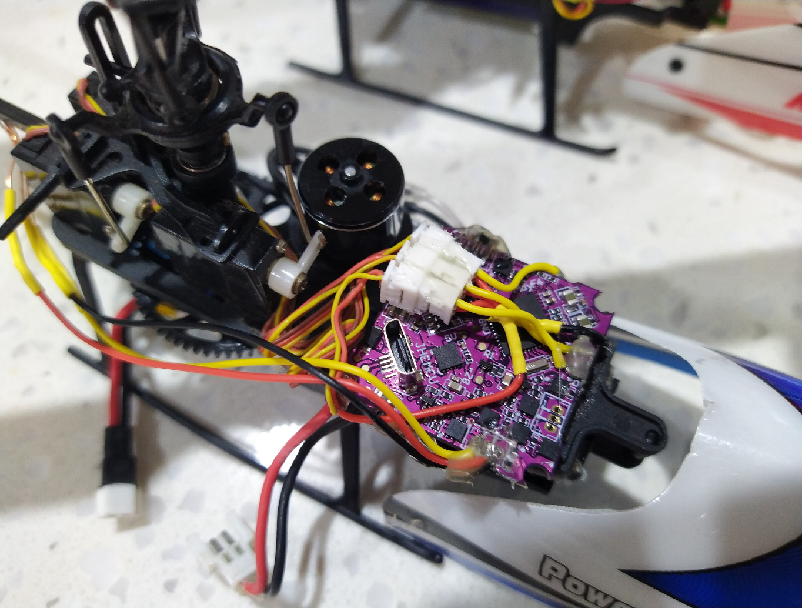

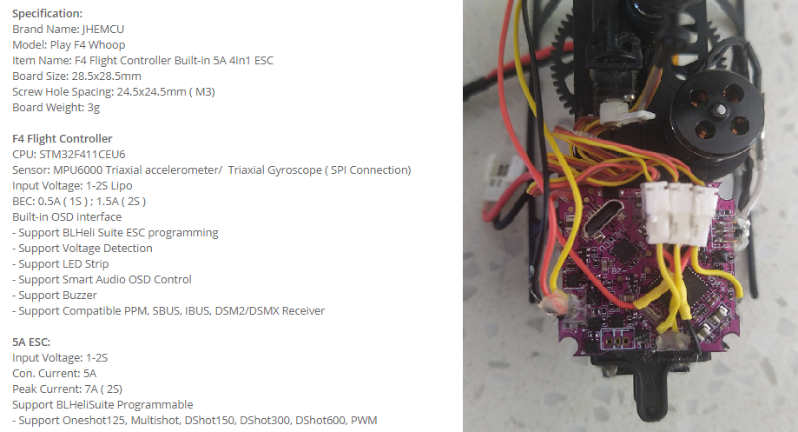

Motor and Servo Wiring.

I used 3 Micro JST 1.25 plug connectors to suit the k110 servos. The signal wires of these sockets are connected to the pins shown below. The servos on the k110 are 1s so I connected the positive of each connector to the battery supply. GND for each socket are wired together then to GND.

Please note the Main Motor (assigned motor 1 in the code) is connected to the Motor 2 on the ESC and the Tail Motor (assigned motor 2 in the code) is connected to the motor 3 on the esc.

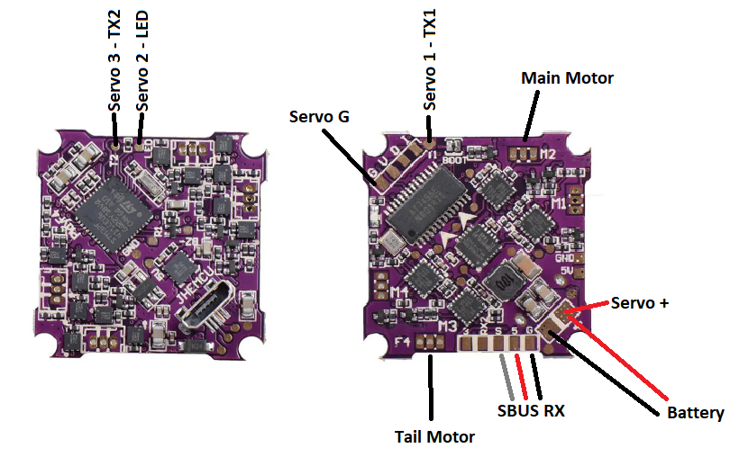

Configuration:

1. Download Betaflight. I’m using version 10.6.0
2. Open and select Update firmware

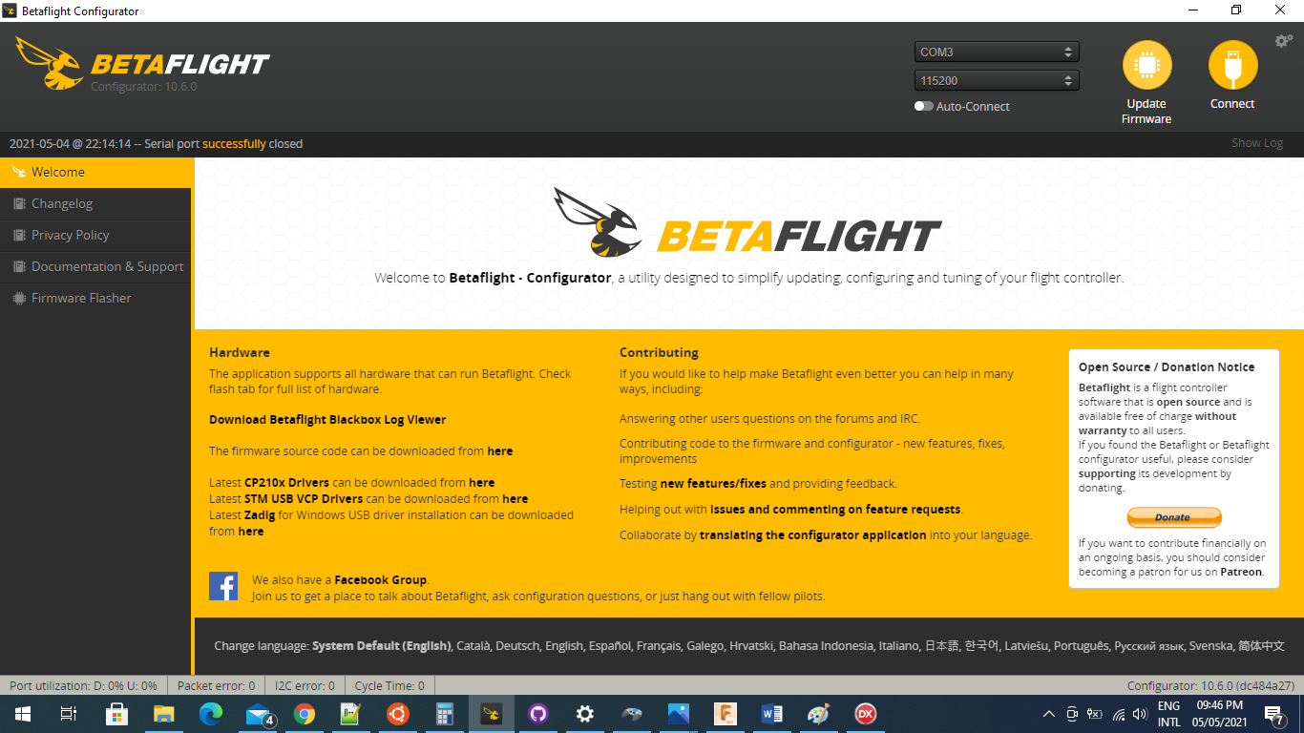

1. Load Firmware [LOCAL] and select the Hex file from the Zip files. This processor is the STM32F411 target. Set the “Full Chip Erase”

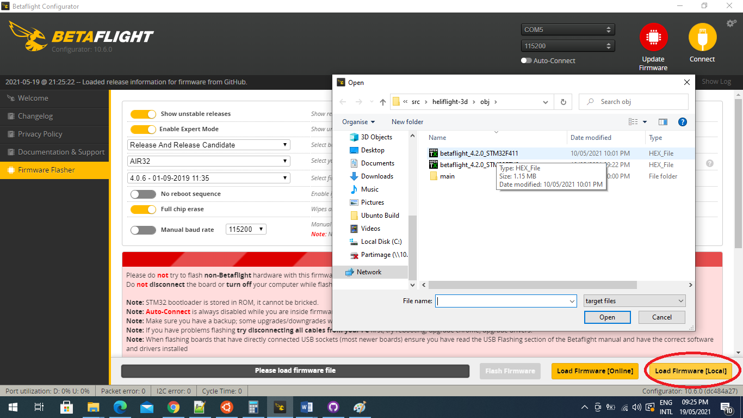

1. Wait for the Programming Successful and click “Connect”

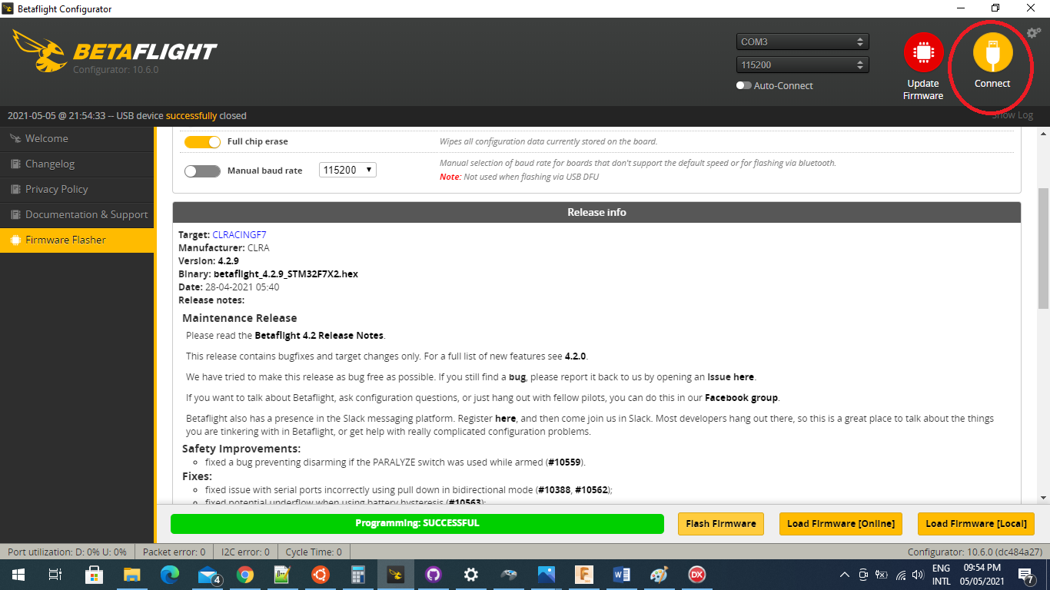

1. Apply custom defaults (it will say there are none which is ok)

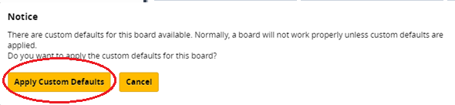

1. Reconnect and select CLI

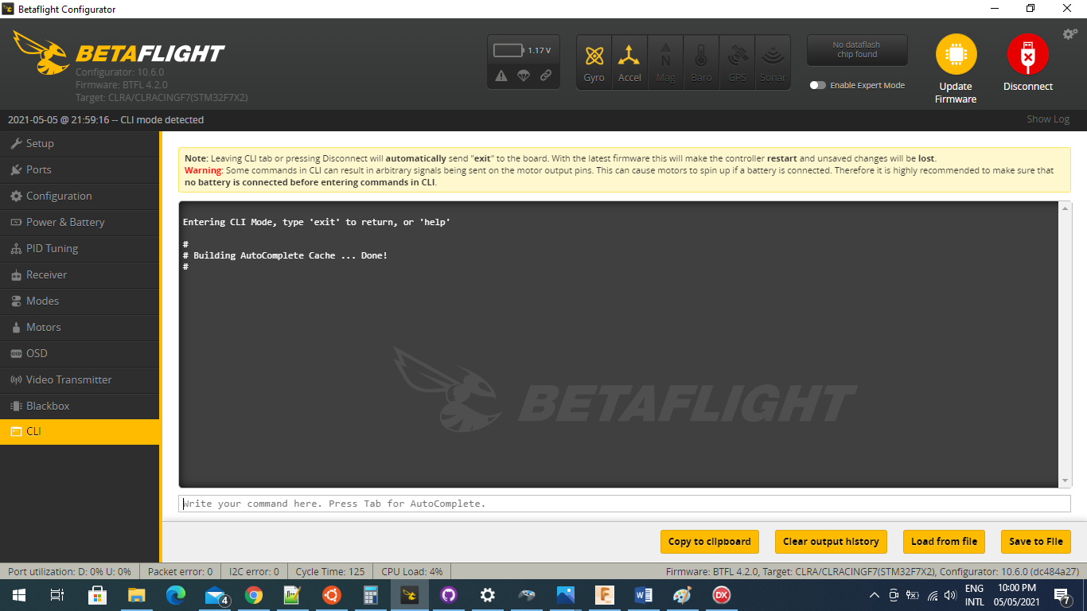

1. Open the PlayF4_Dump.txt file. Select all of the text in the file (ctrl A) and copy (ctrl C).

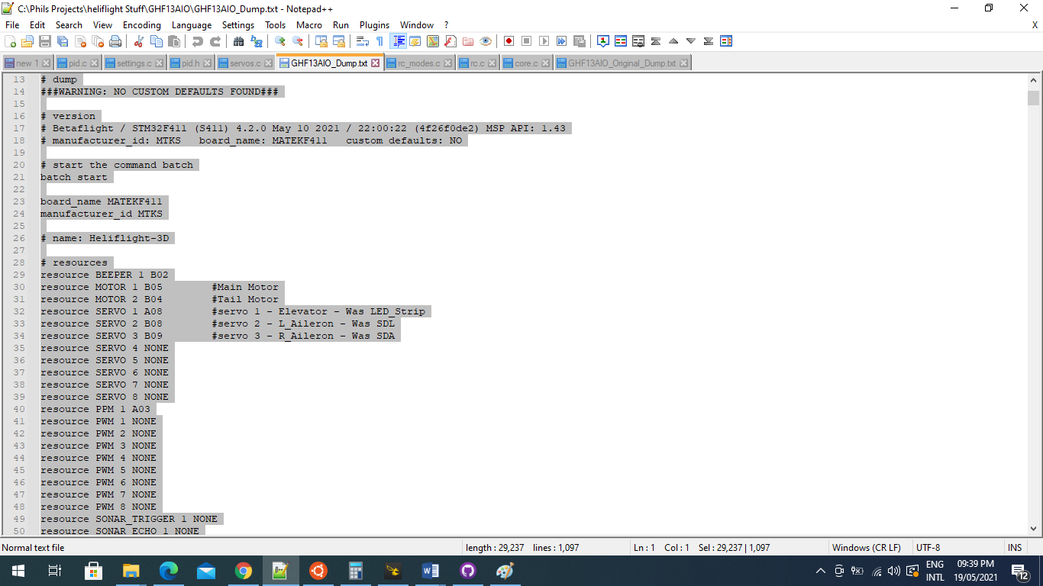

1. Paste this into the Betaflight CLI and click ENTER (down the bottom where it says write your command here). The settings will then be loaded.

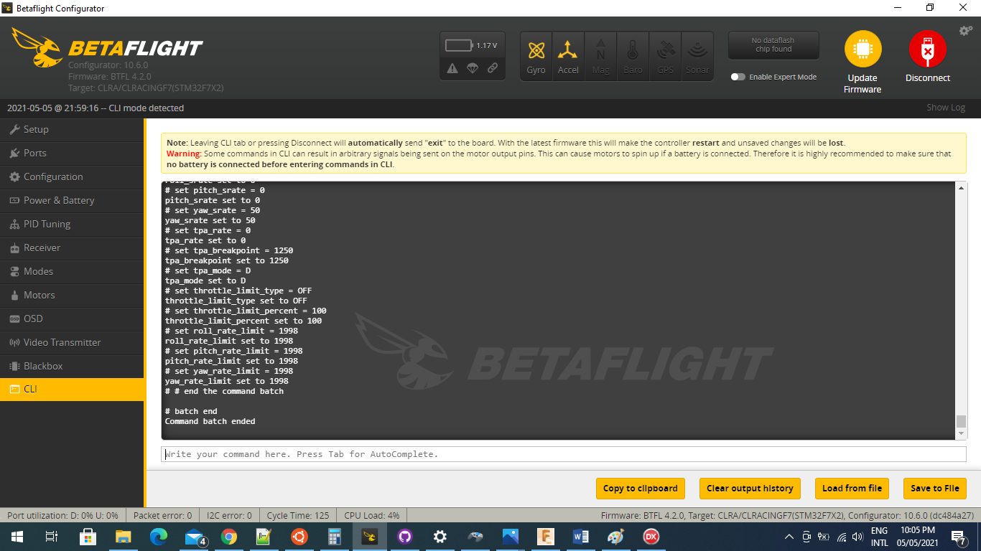

1. In the CLI type: save [ENTER] (really important. Config won’t be saved if you don’t save….)
2. Now we need to set up the bi-directional Dshot so that the motor speed telemetry functions. This FC has BLHeli_s ESC’s which don’t natively implement bi-directional Dshot. There are three options for this. JESC (paid), BLHeli_M or Bluejay like I have used…..

Go to the Bluejay configurator. Please note this is a test version which enables each ESC to be loaded with different settings. https://esc-configurator.com/. Click on Settings and tick the disable common settings so you can load different settings for the tail and main motors.

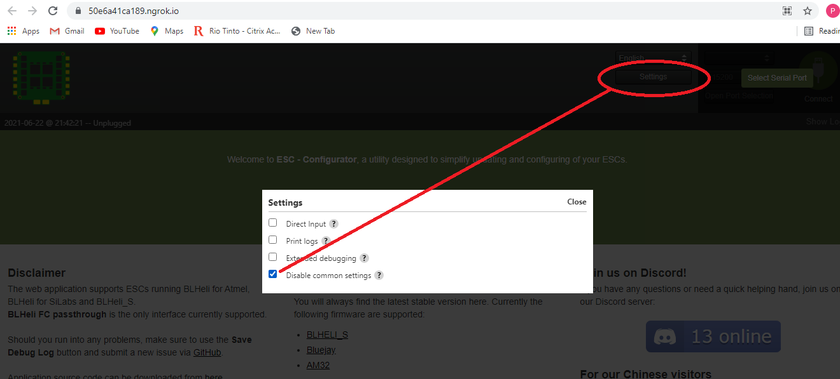

1. Connect and read setup. Scroll down to the ESC 2: Select firmware

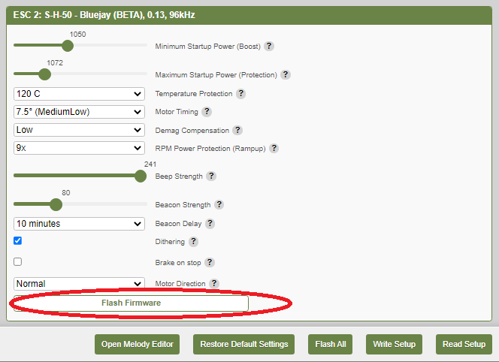

1. Select [Flash] as below. Version 0.13 or 0.14(TEST VERSION) implements the Bi-directional Dshot. I used the 96kHz for the tail.

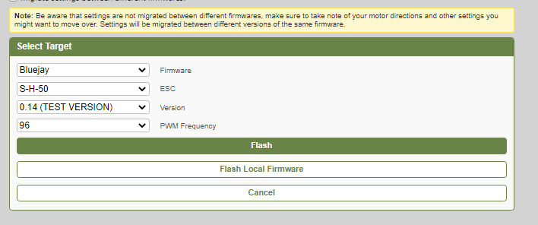

1. After flashing is complete. Set up parameters for the tail and write setup. These are what I have.

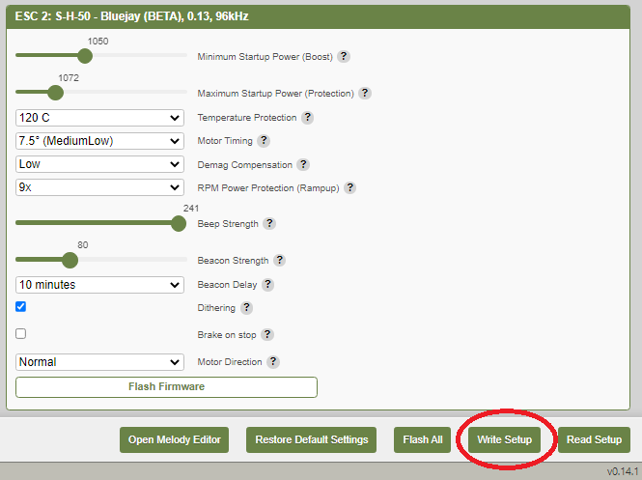

1. Scroll up to ESC 1: This ESC should be set up without damped-light mode. This is done by flashing the ESC firmware file as supplied in the zip file. Select either the 24, 48 or 96 kHz version. I used for the 48kHz for the main.

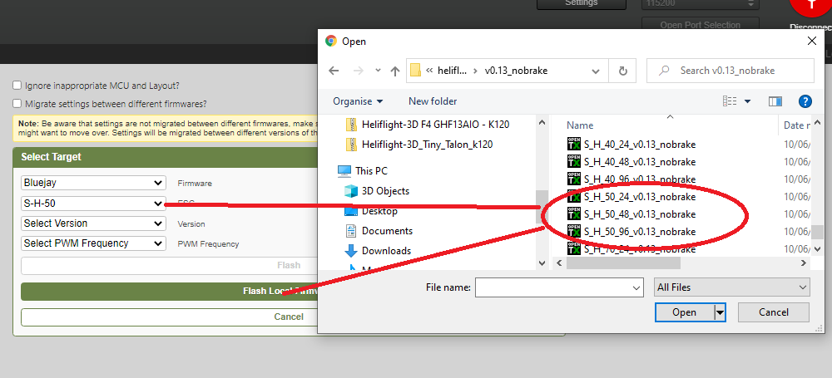

1. After the firmware is downloaded set the configuration and [Write Setup]

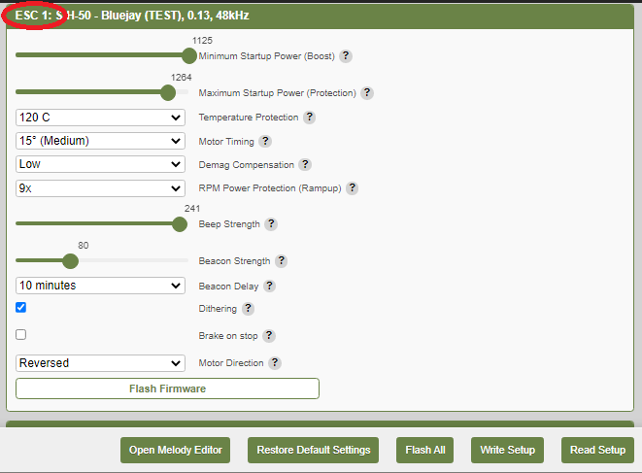

1. If you are particularly nerdy….. Give the melody editor a try. This changes the startup tone of the ESC’s (seriously though you will be judged harshly if you chose the Rick Astley one)

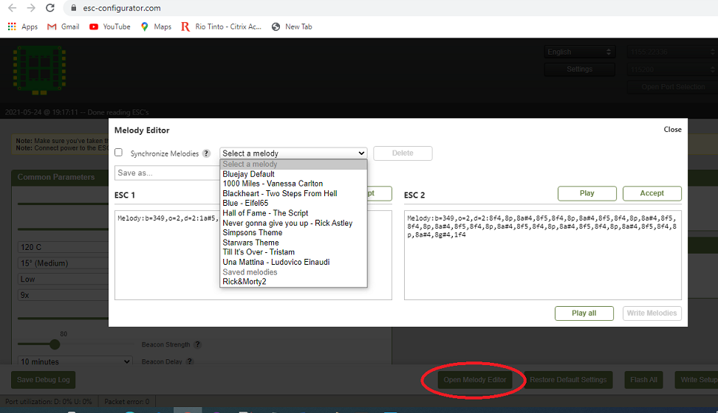

1. Open Betaflight again and connect. In the Configuration tab select the Motors tab. With the battery powered on, check the bi-directional Dshot is working. It should look like this (E: 0.00%). If it is (E: 100.0%) it is not working and you should review loading Bluejay.

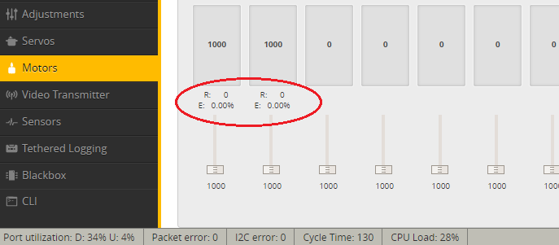

1. Configuration tab select your preferred receiver. Mine is SBUS so that’s what is configured in the dump file.
2. Open the receiver tab and make sure your radio is set up to centres and operating correctly. The PITCH has to be on ch5. I have a FUTABA so pitch is natively CH6 so had to mix CH6 it to CH5. Your radio channel map needs to be AETR1234.
3. Adjust the stick centre and trims on your radio so they are the same and the FC does not see a stick input with the sticks at centre.

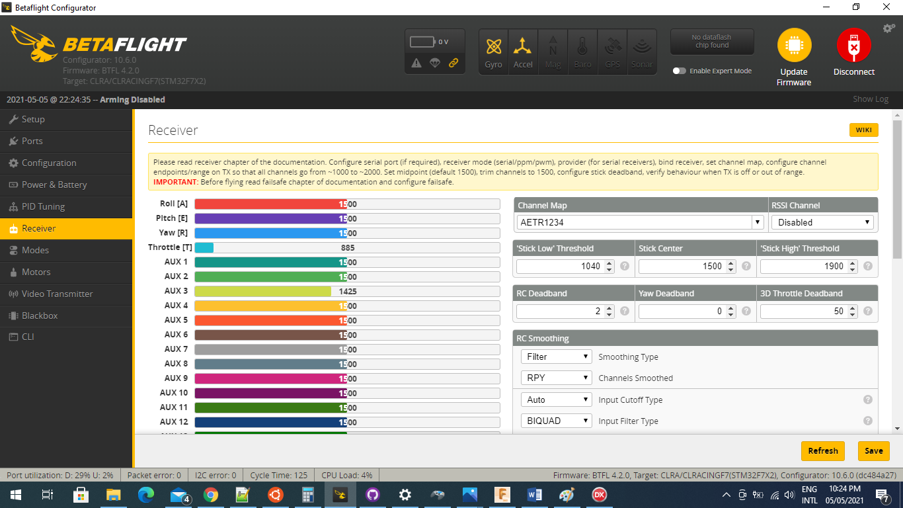

1. In the modes tab set up switches to operate the ARM and ANGLE modes. Selecting the ANGLE mode enables the rescue mode. Horizon mode can be configured if 6G mode is desired.

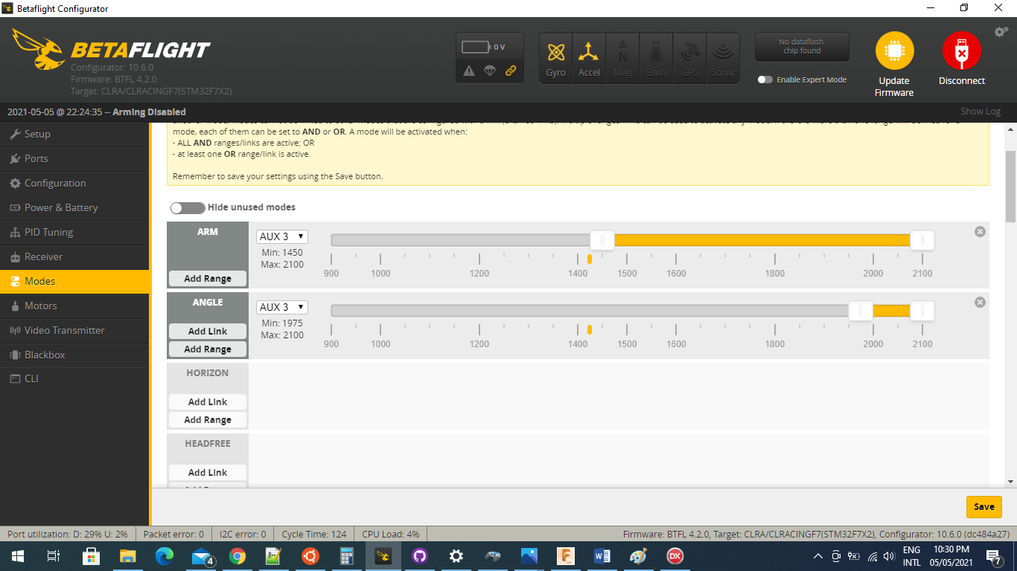

1. On the Setup tab calibrate the accelerometer. Make sure it is nice and level

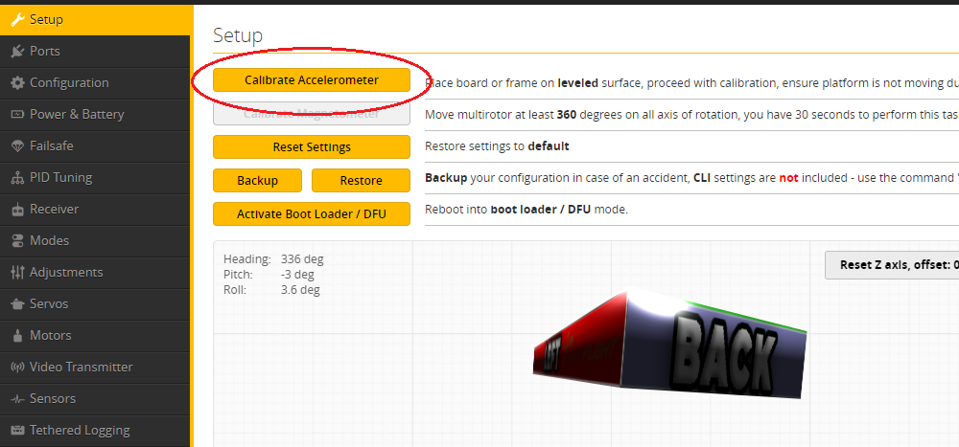

1. Setting up servos. Set the enable expert mode and click the servos tab. The servo numbering does not line up. Servo 1 is configured via Servo 2 etc shown in the pic below.

a. Change the mid point until the servo horn is in the right position. [Save]

b. Change the min and max to be equal values above and below the mid point. The range (difference between the min and max) for each servo can be changed so that the Blade angle positive and negative are the same depending on head geometries. I’m not that technical so I just make them the same. In the example below I shifted the servo 2 up by 50. [Save]

c. Check the servos have full range of movement without binding. If not you will need to reduce the servo range.

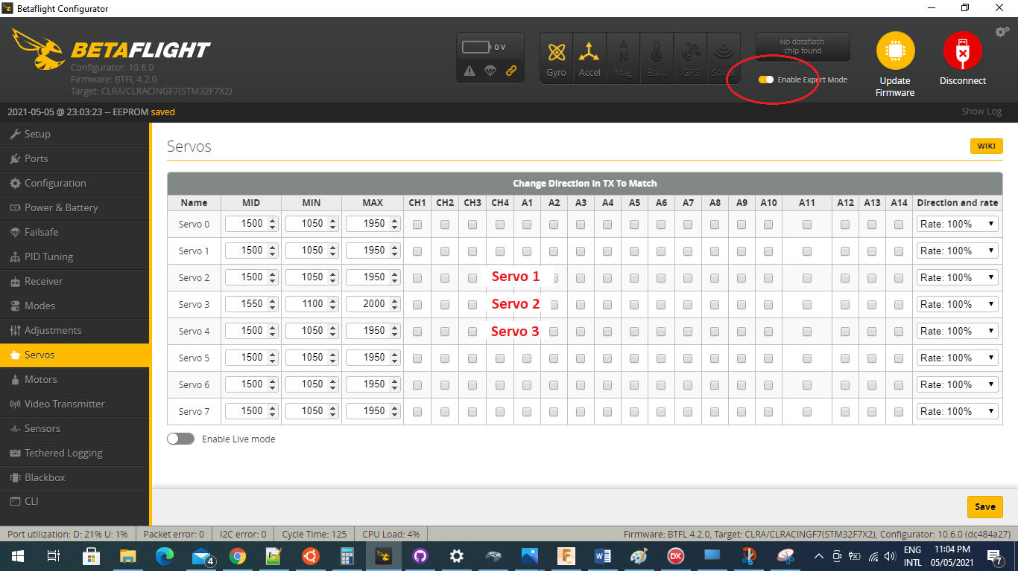

1. Backup your files once you are done. Open the CLI and type: Dump [enter]. Select, copy and paste the entire output into a text file and save it. This is your dump file with all of your configuration. If you re-flash firmware or build another FC use your file at step 7.

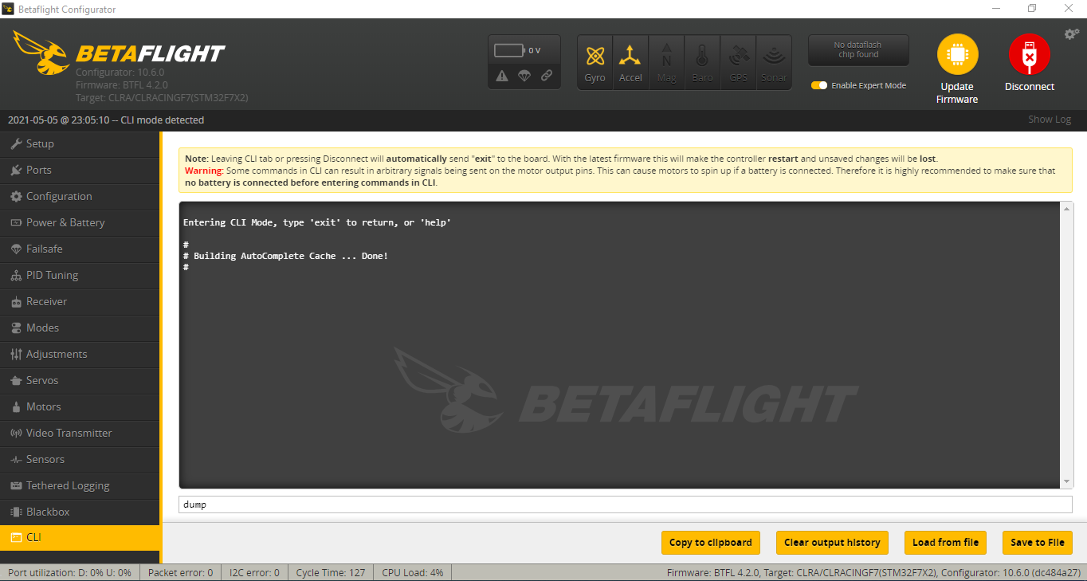

That’s it. Go fly.

PID tuning

It should be quite flyable with the PID parameters as they are. If you want to change these settings you can do it through the PID tuning tab.

